1. Interface Profile
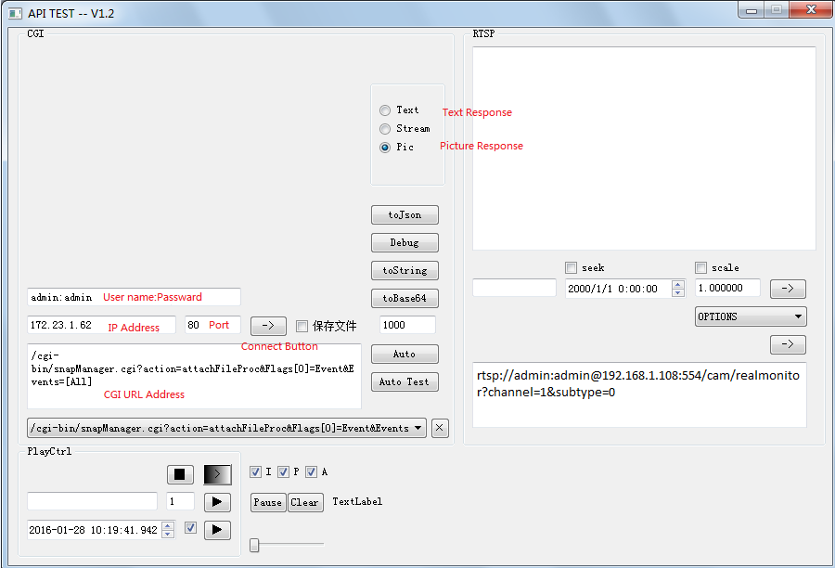

2. The button pattern will be ‘X’ when you click on the ‘Connect’ button.
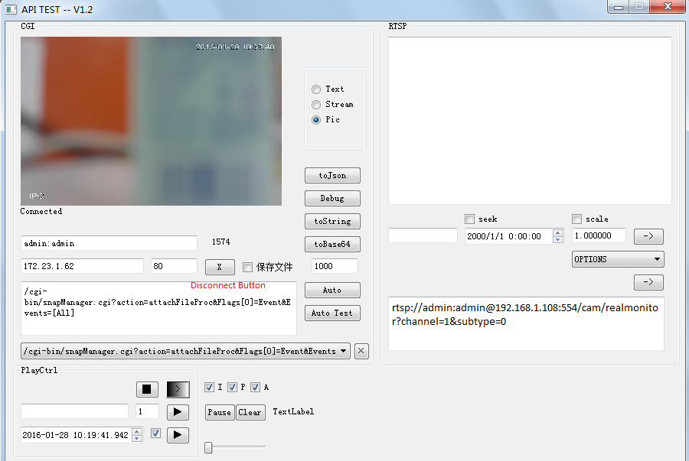

3. Switch to ‘Text Response’, you could view the photo of event information.

