intelligent_door_stat_CRT_log
Scope of application：all of the intelligent building equipments

- First we need to enable SSH on the device. For VTO（or ASI）, we can enable it on web page, as shown below:
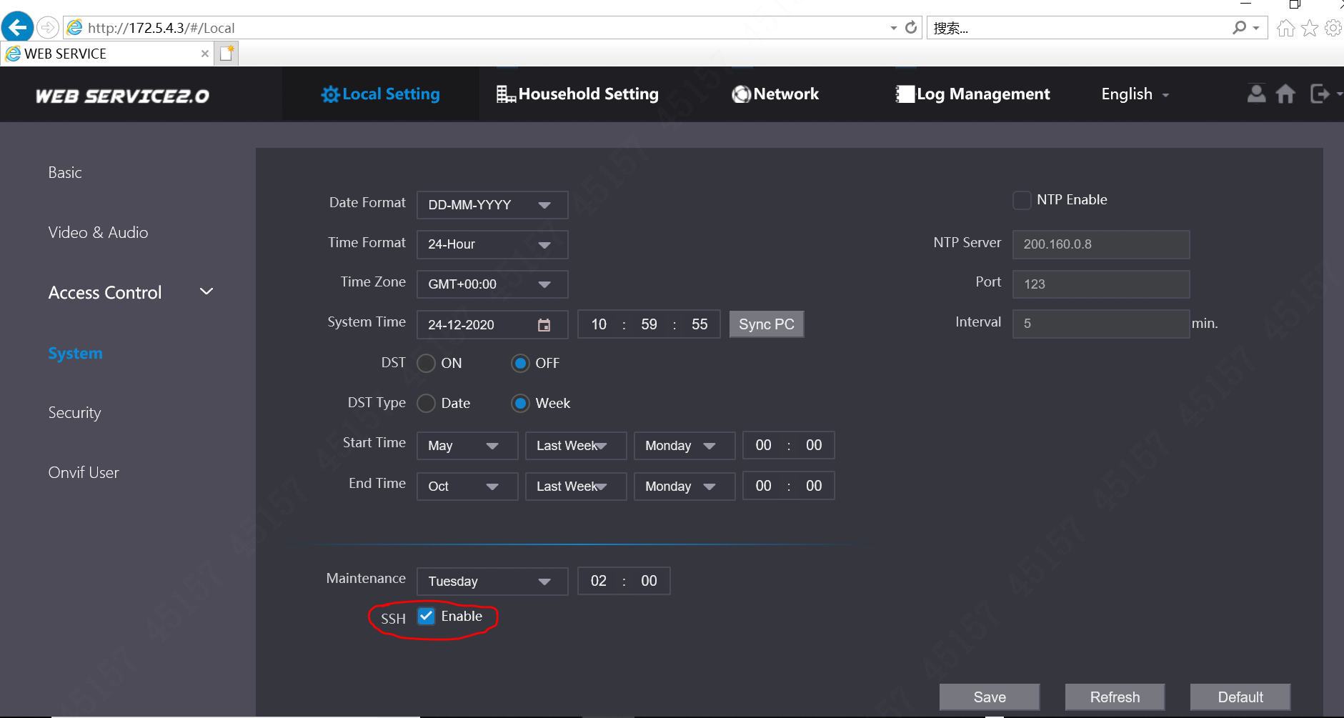
For VTH, we can set it here:
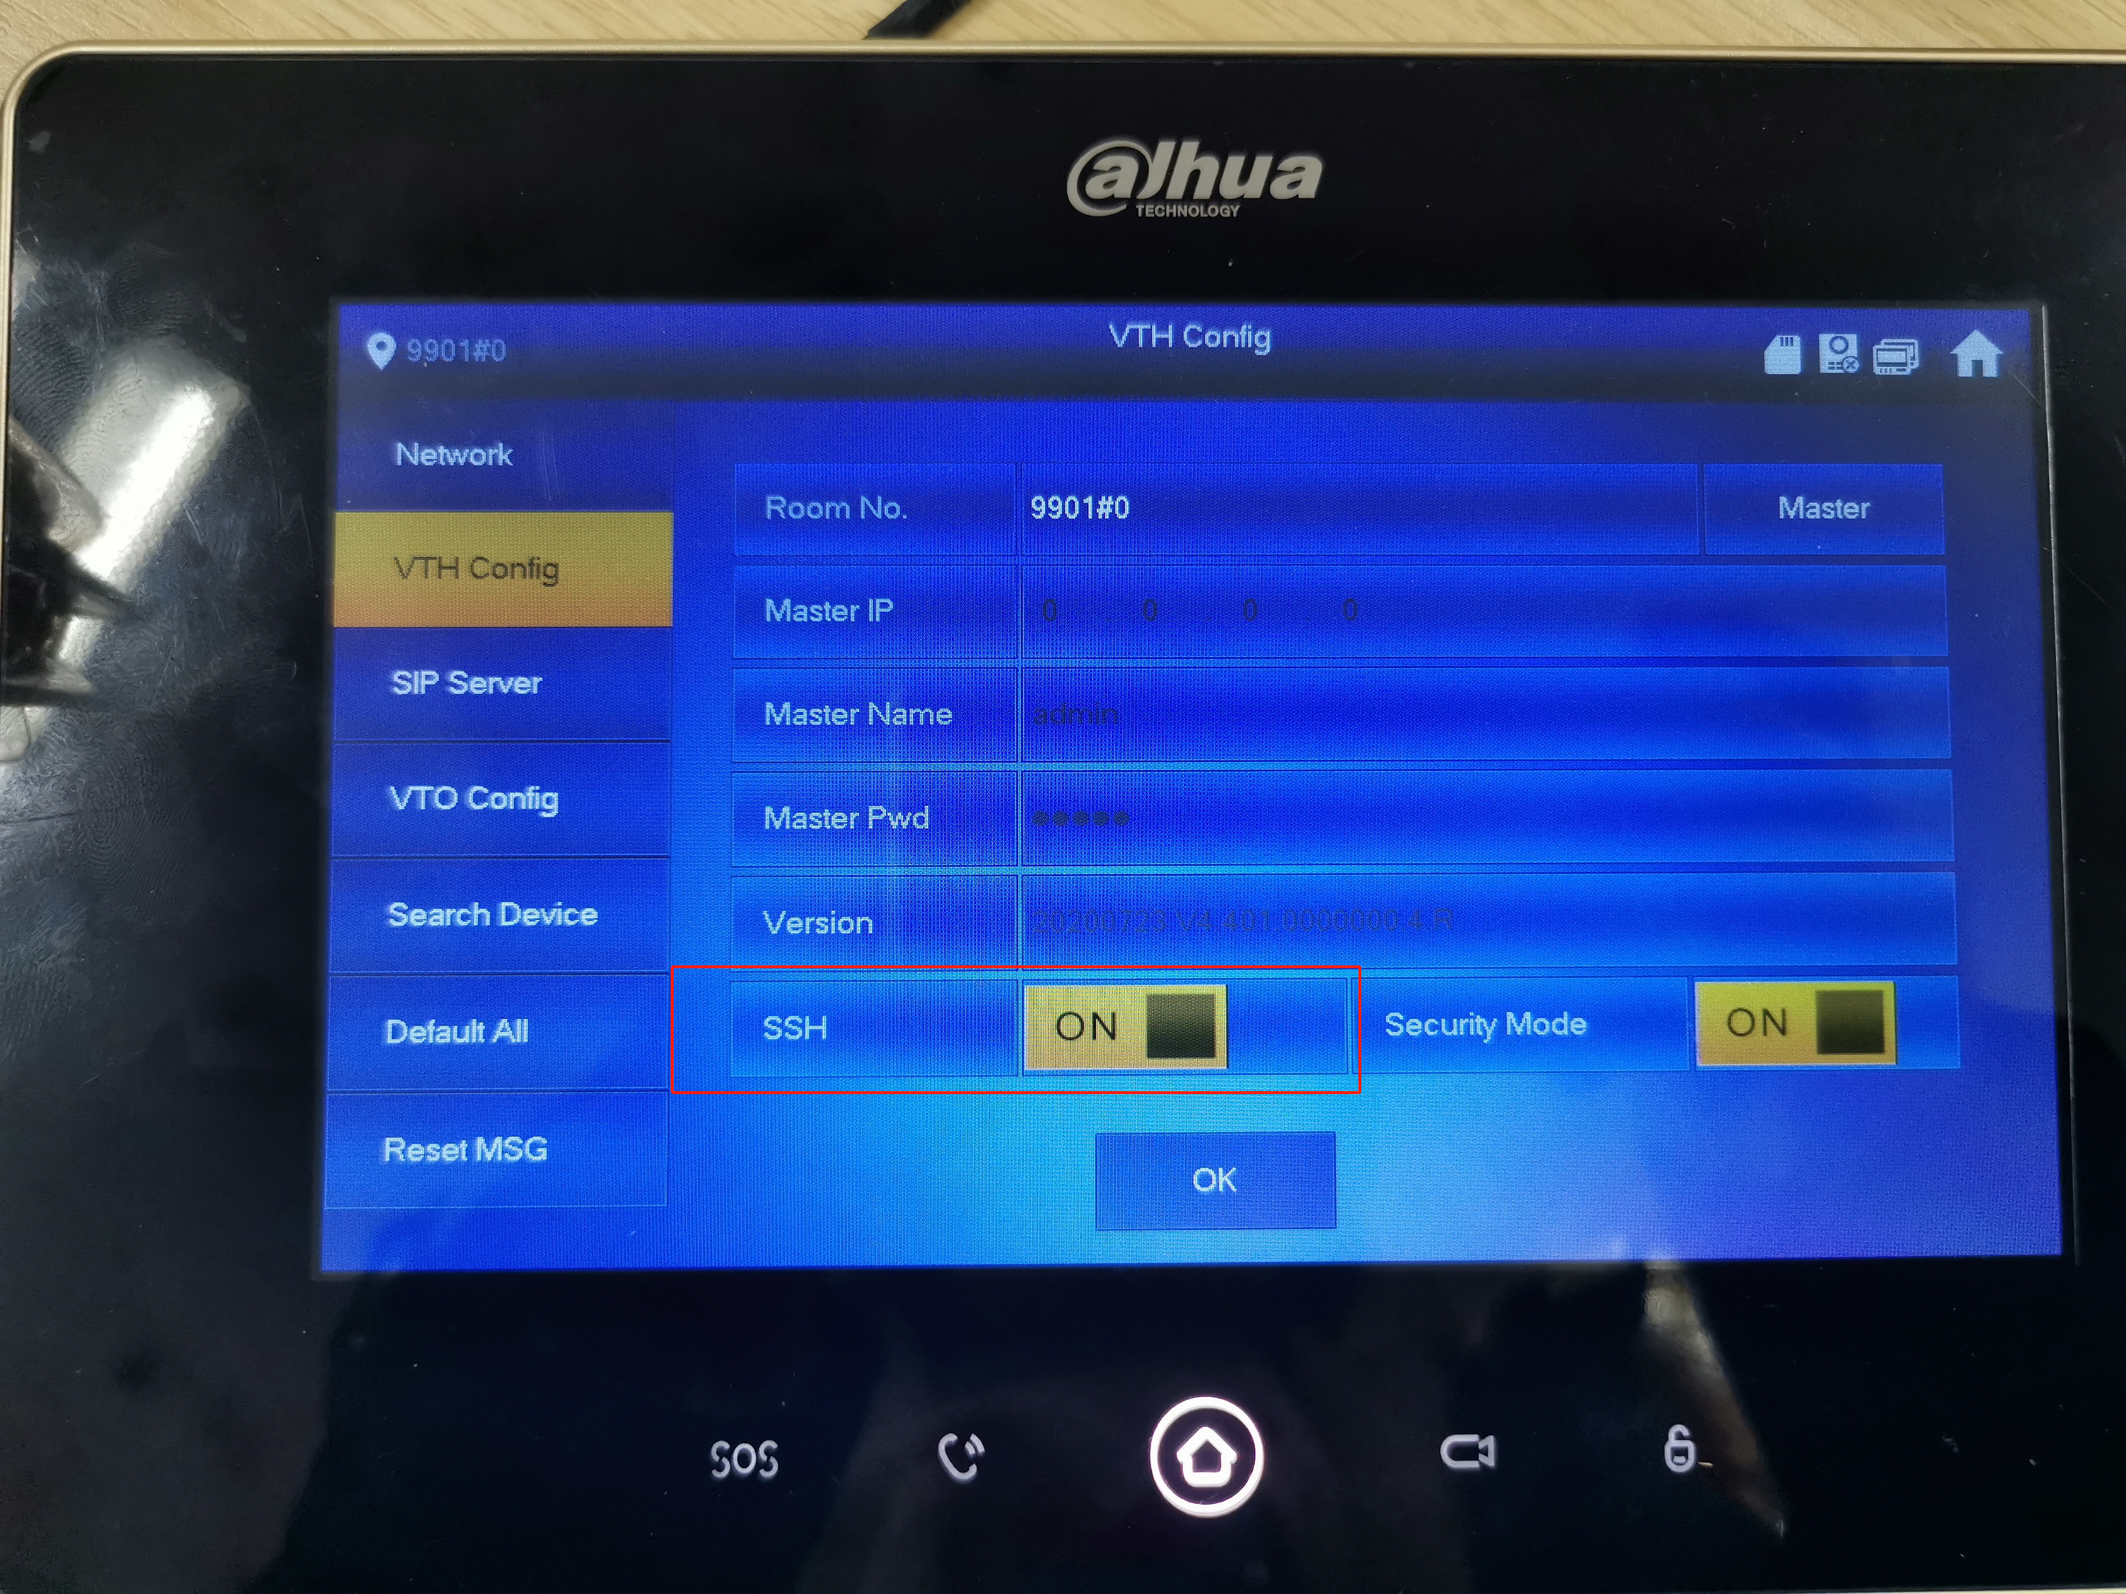
We can also use cgi command to enable SSH:
http://device IP/cgi-bin/configManager.cgi?action=setConfig&SSHD.Enable=true

Enter the address and we will see the log-in interface. Enter the account name and password, and then click the login button.
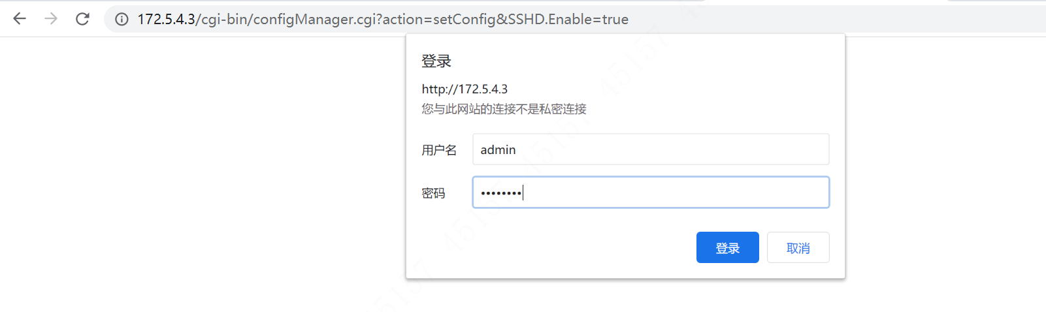
If it returns “ok”, then SSH enables successfully.
2. Connect to secureCRT
STEP1：Open quick connection—the second item from left, as shown below.
STEP2：Fill in the corresponding information in the pop-up
Hostname: device IP
Username：device account name(normally--admin)
Port number：22
Click connect when finish all above.
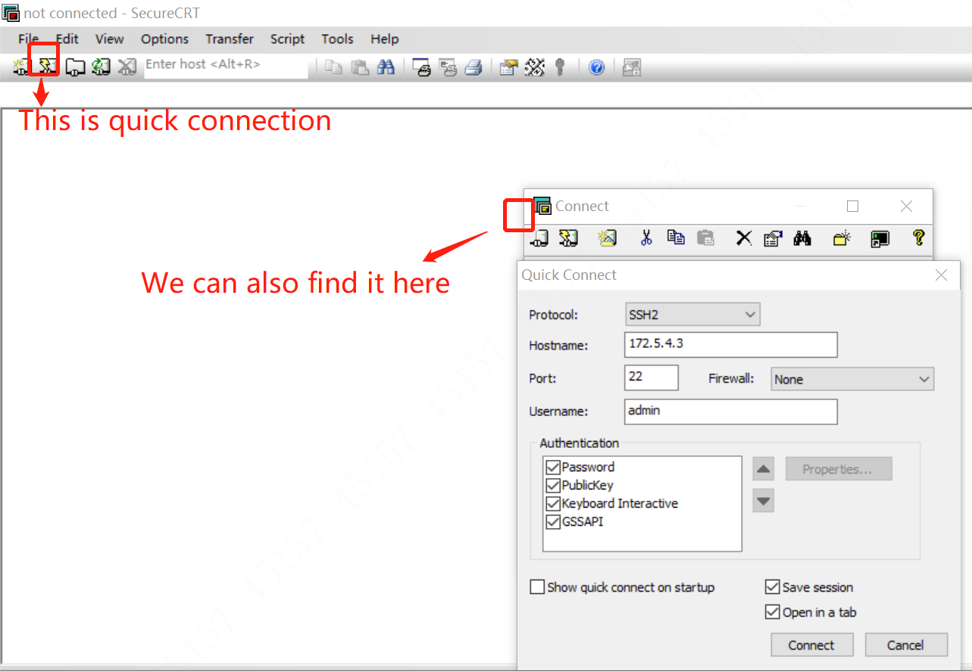

3. Fill in the account information in the pop-up
Note that username is the device account name---normally admin.
Password is 7ujMko0+device password(Note that here “M” is an upper letter.) The plus makes no sense, just to remind you of adding “7ujMko0” before device password.
(For example, if the VTO password is admin123, so the password is 7ujMko0admin123; For VTH or VTS, if the project password is 123456, then the password is 7ujMko0123456 ).

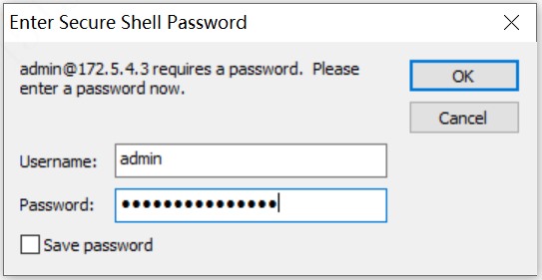
And click OK to connect with CRT.
4. Open chat window in the navigation bar: View->select ”chat window”.
5. Change appearance and character encoding.
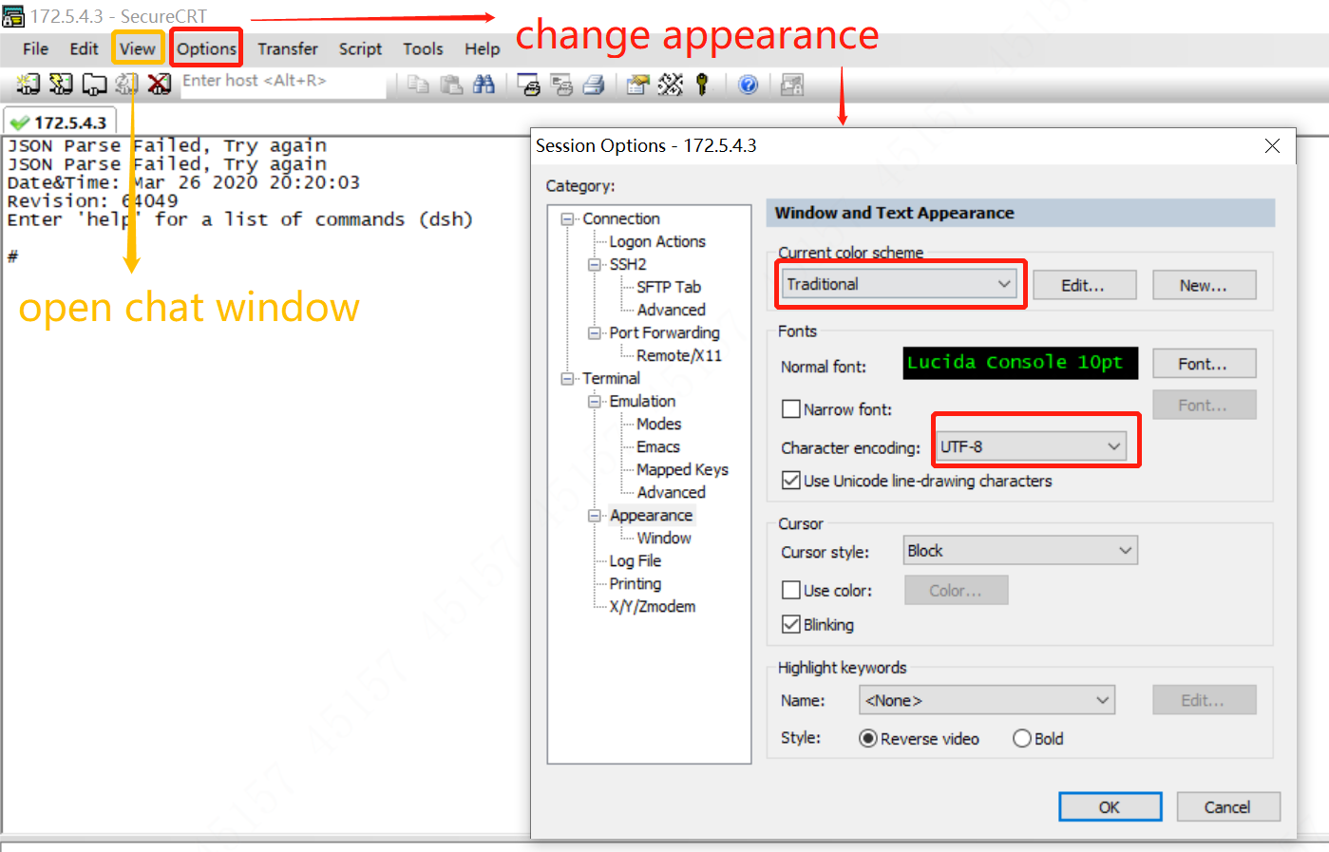
6. When you see the hash—“#”, which means success, we can enter shell.
Enter shell and your domain account.
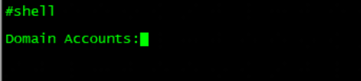
7. It will return a QR code:
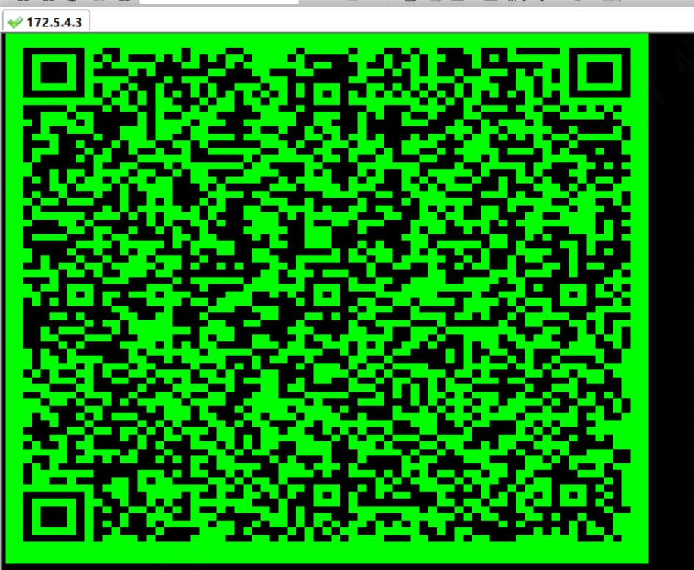
Scan it and put in your domain password, then we can get a check code.
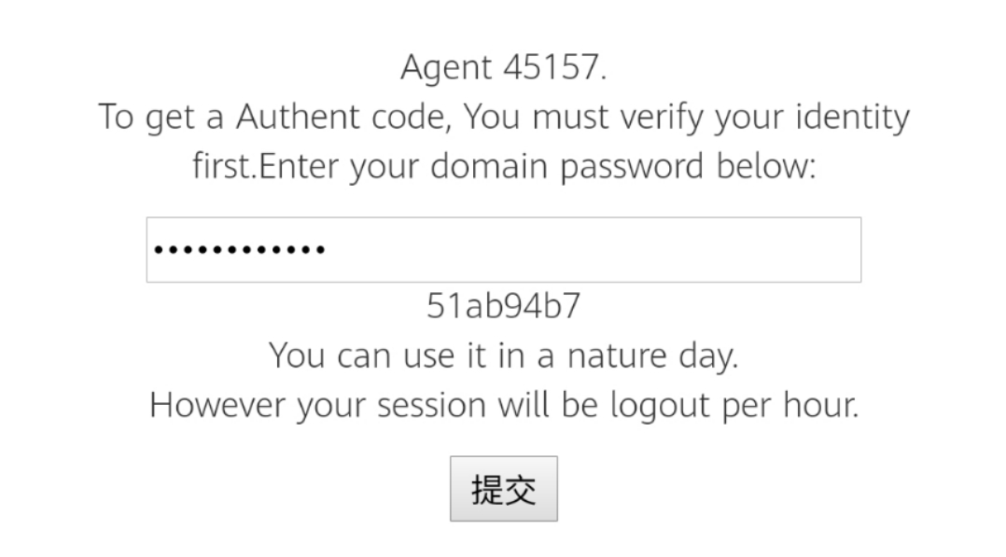
8. Type in the check code in CRT.
9. Now we are ready to start printing session log.
Type in dh_keyboard 0 to open log printing.
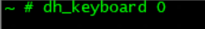
When it shows “save ok”, as shown below, we can type in the command-- printcli, to start printing.
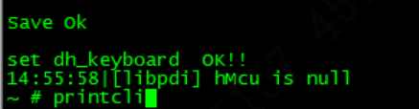
10. Do not forget to save the log, otherwise, we have no access to review the log session.
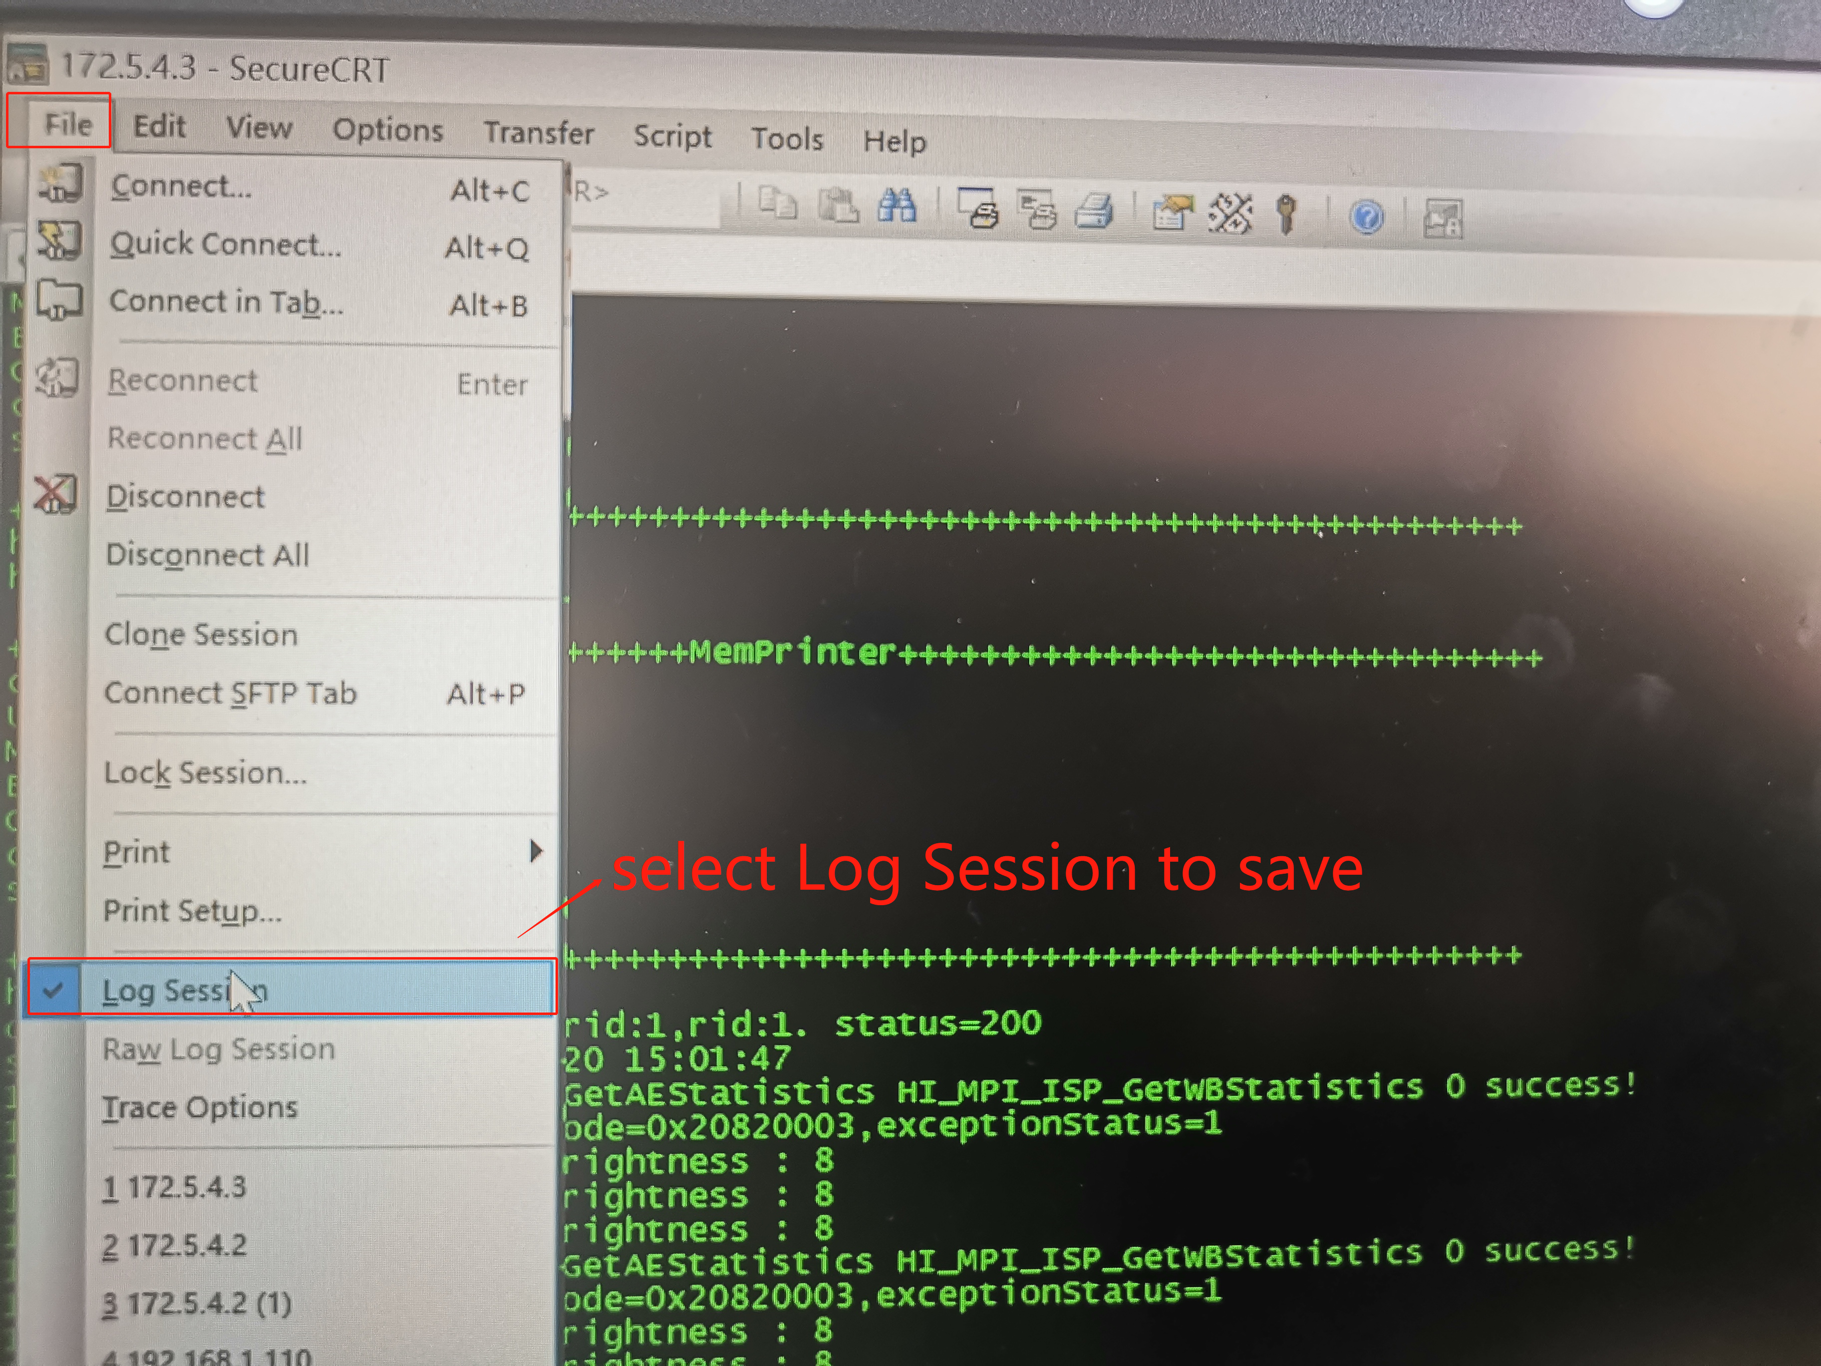
It will pop up a window to select where to save the file.
11. If we want to open deep mode, we need to type in the username and password.
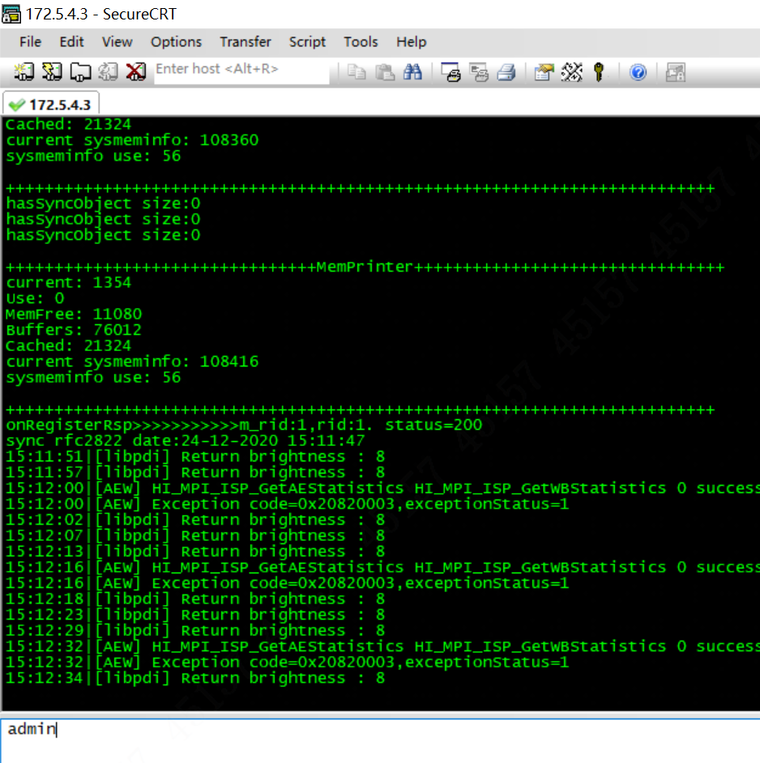
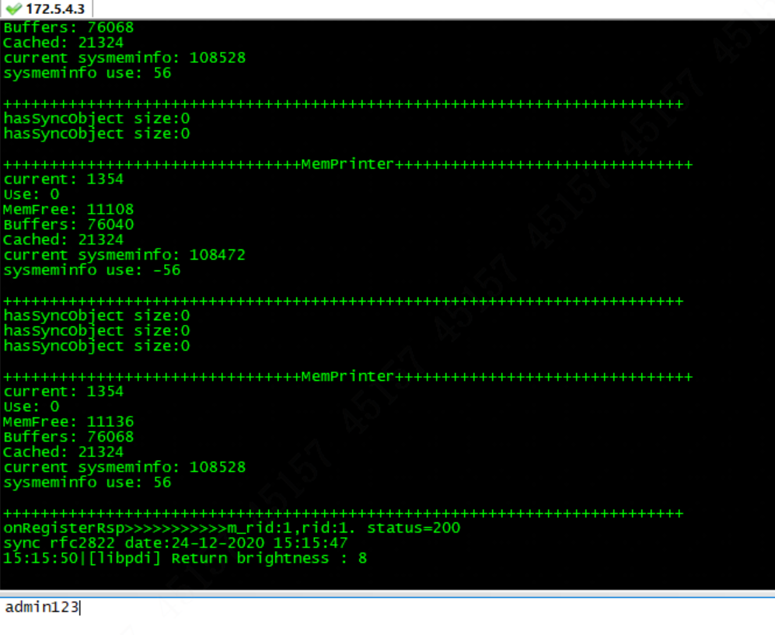
When the symbol after the username becomes dollar(“$”), we successfully log in the deep mode.
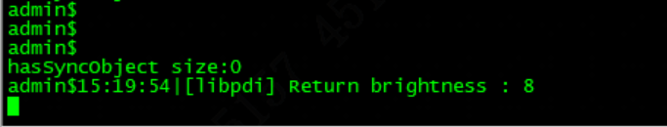
12. Then put in the command: print -l 6 to start deep printing.
And it will remind us of a message to show success: print Level will Set To 6!
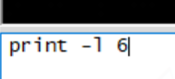
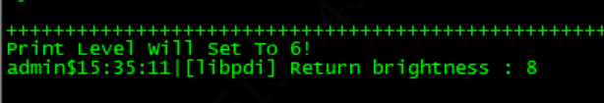

13. Finally, if we want to capture logs from all-in-one access controller, we need to add one more command: pm –printconfig 1 , to open information echo.

14. Once the problem reccurring, reconnect CRT and enter shell again, Then stop printing logs by using the command: dh_keyboard 1. And then reboot the device. (Note that it will affect the device performance with long period of printing, we should stop printing after the capture is finished.)

