Release Notes

Release Notes
Keywords: Version information, version upgrade
Abstract: This document provides detailed version information and upgrade procedure for
GIPC-B6203.8.5.C00003.NB.221208/ GIPC-B6203.8.5.C00003.221208.
Acronym:
Acronym | Full Name
IPC | IP Camera

Content
1 Version Information 3
1.1 Version Number 3
1.2 Release History 3
1.3 Version Mapping Table 3
1.4 Feature and Change Description 4
2 Version Upgrade Procedure 4
2.1 Upgrade Overview 4
2.1.1 Version Upgrade Environment 4
2.2 Upgrade Procedure 4
2.2.1 Upgrade Through the Web 4

Version Information

Version Number
GIPC-B6203.8.5.C00003.NB.221208
GIPC-B6203.8.5.C00003.221208

Release History
Table 1 Released versions
Version No. | Basic Version No. | Released On | Remarks
GIPC-B6203.8.5.C00003.NB.221208 | GIPC-B6203.6.12.C00055.NB.221122 | 2022-12-13 | Improved release

Version No. | Basic Version No. | Released On | Remarks
GIPC-B6203.8.5.C00003.221208 | GIPC-B6203.6.12.C00055.221122 | 2022-12-13 | Improved release

Version Mapping Table
Table 2 Product models and corresponding versions
Product Series | IPC Series
Series | IPC3638SB、IPC2328SB、IPC2128SB
Models | IPC3638SB series: IPC3638SB-ADZK-I0-NB
 | IPC2328SB series: IPC2328SB-DZK-I0-NB
 | IPC2128SB series: IPC2128SB-ADF40KMC-I0-NB
Target file name | GIPC-B6203.8.5.C00003.NB.221208.zip

Product Series | IPC Series
Series | IPC3638SB、IPC2328SB、IPC3238SB、IPC2128SB、IPC3618SB、IPC328SB、IPC815SB  IPC2128LE、IPC328LE、IPC3618LE、IPC2228SE、IPC3638SE
Models | IPC3638SB series:IPC3638SB-ADZK-I0
 | IPC2328SB series:IPC2328SB-DZK-I0
 | IPC3238SB series:IPC3238SB-ADZK-I0
 | IPC2128SB series：IPC2128SB-ADF28KMC-I0、IPC2128SB-ADF40KMC-I0
 | IPC3618SB series：IPC3618SB-ADF28KM-I0、IPC3618SB-ADF40KM-I0
 | IPC328SB series：IPC328SB-ADF28K-I0、IPC328SB-ADF40K-I0
 | IPC815SB series：IPC815SB-ADF14K-I0
 | IPC2128LE series：IPC2128LE-ADF28KM-G、IPC2128LE-ADF40KM-G
 | IPC328LE series：IPC328LE-ADF28K-G、IPC328LE-ADF40K-G
 | IPC3618LE series：IPC3618LE-ADF28K-G、IPC3618LE-ADF40K-G
 | IPC2228SE series：IPC2228SE-DF40K-WL-I0、IPC2228SE-DF60K-WL-I0
 | IPC3638SE series：IPC3638SE-ADF28K-WL-I0、IPC3638SE-ADF40K-WL-I0
Target file name | GIPC-B6203.8.5.C00003.221208.zip

Feature and Change Description
None.

Version Upgrade Procedure

Upgrade Overview

Version Upgrade Environment

Network Architecture for Upgrade
Figure 1 Network architecture
As shown in this figure, the version files are stored on the PC that is connected to the IPCs through the network.

Upgrade Procedure

Upgrade Through the Web
        - Log in to the Web interface as admin (default password: 123456).
        - Click Setup > Maintenance > Device Maintenance. The Device Maintenance page is displayed.
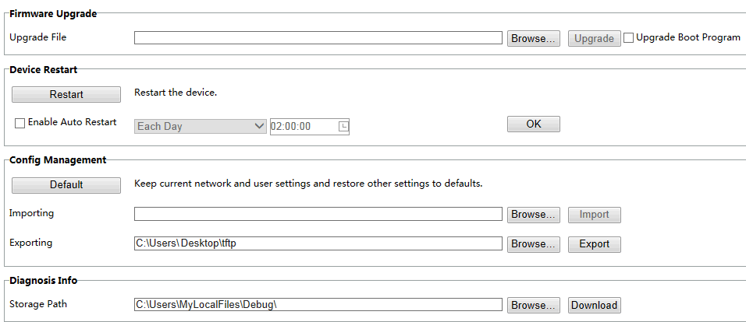
        - Click Browse in the Firmware Upgrade area. In the Select dialog box that appears, select the upgrade file package, for example, IPC_G6203-XXXX.zip, and then click Open.
        - Click Upgrade. You cannot operate on other pages during the upgrade process.
        - Wait till the upgrade is completed. A message appears to indicate successful upgrade and prompt you to log in again after the device restarts.

No part of this manual may be reproduced or transmitted in any form or by any means without prior written consent of our company.
The information in this manual is subject to change without notice.

