1. Start menu 🡪 Cinfin🡪 Get registration code

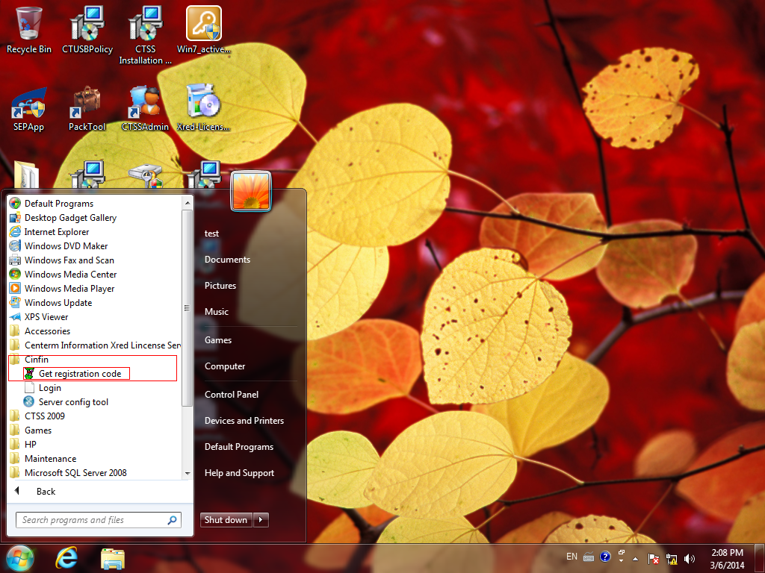

1. Press “ Generate”

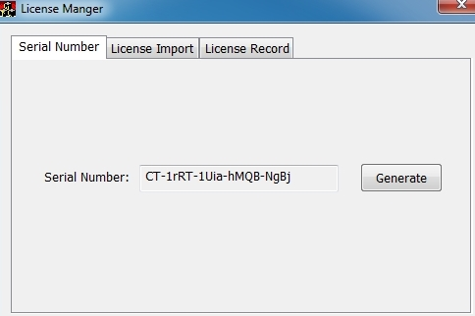

1. Send back the Serial Number to us
2. Import of coming licence

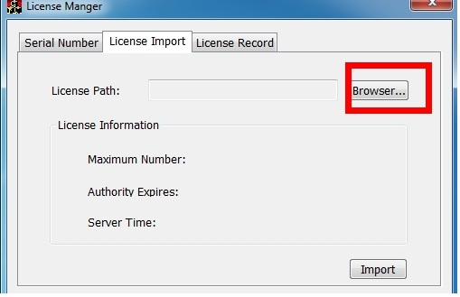

Eventually move the registration file there C:\Program Files (x86)\CDMS\runtime\bin

and restart CCCM software